Design and Analysis of Algorithm
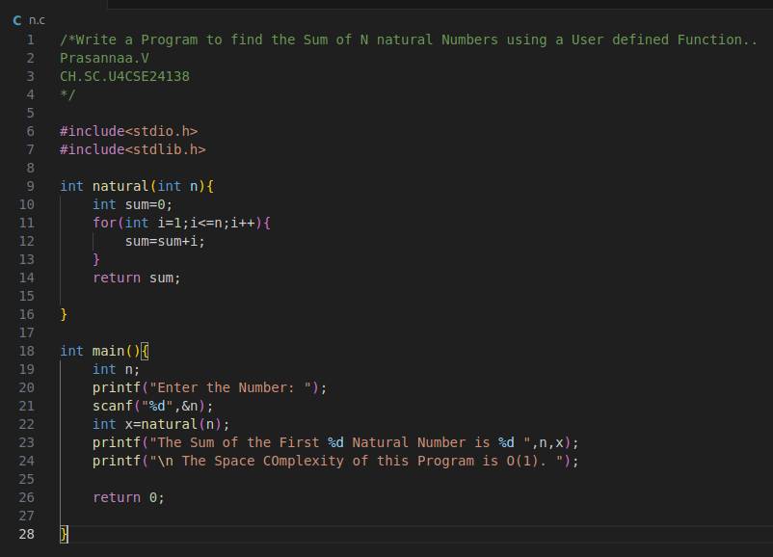
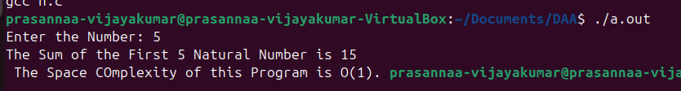
Justfication:
The Space Complexity of this program is O(1) because the program uses only a constant number of variables (n, x, sum, i).
These variables do not depend on the input size n

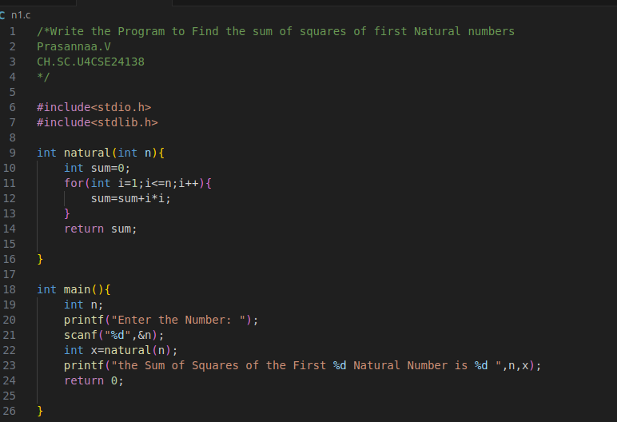
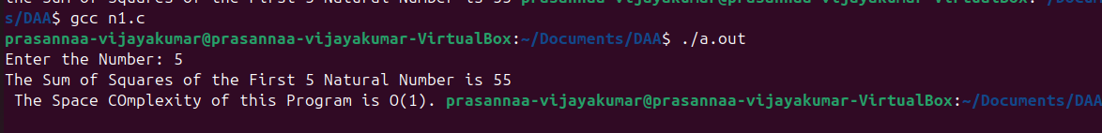
Justfication:
The Space Complexity of this program is O(1) because the program uses only a constant number of variables (n, x, sum, i).
These variables do not depend on the input size n

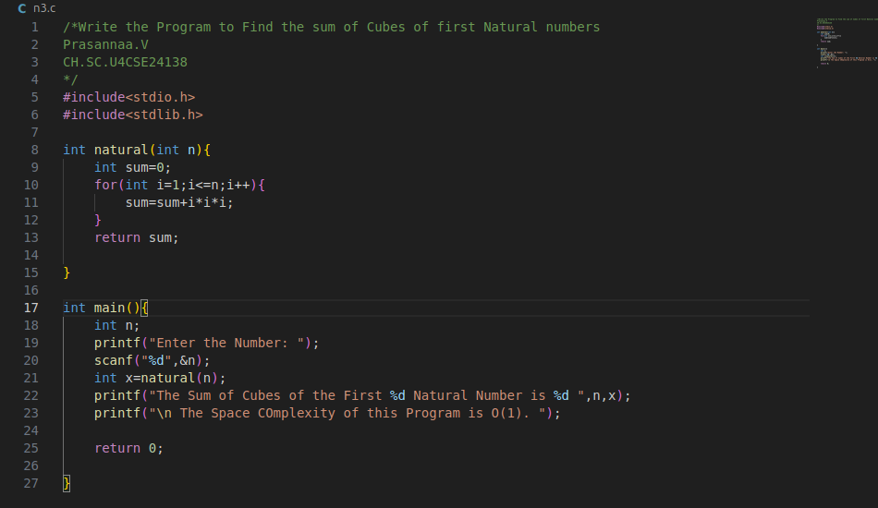
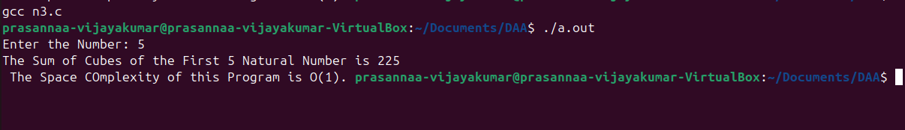

Justfication:
The Space Complexity of this program is O(1) because the program uses only a constant number of variables (n, x, sum, i).
These variables do not depend on the input size n

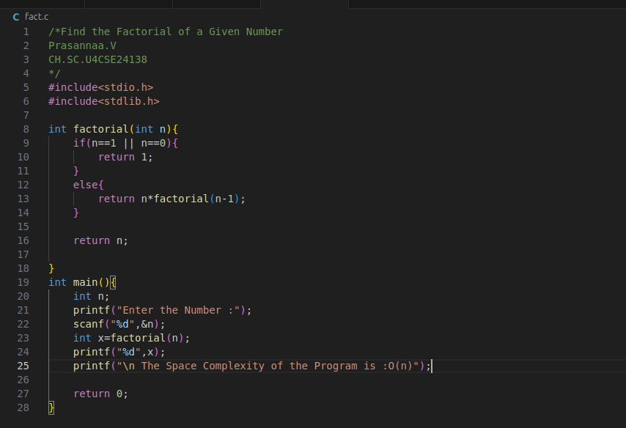
Justfication:
The space complexity of this program is O(n) because the factorial function uses recursion, and each recursive call stores its own set of variables (n) in the function call stack.
For an input n, the function makes n recursive calls before reaching the base case.
Thus, the call stack grows linearly with n, resulting in Space Complexity = O(n).
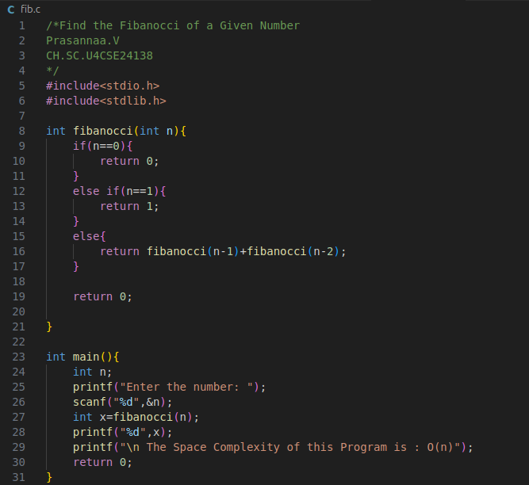
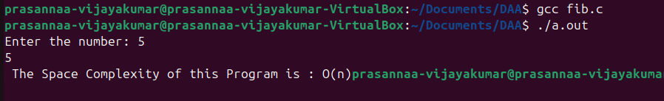

Justfication:
The Space Complexity of this program is O(n) because the program uses recursion and the maximum number of simultaneously active recursive calls (the recursion depth) is proportional to n; therefore the stack space grows linearly with n.
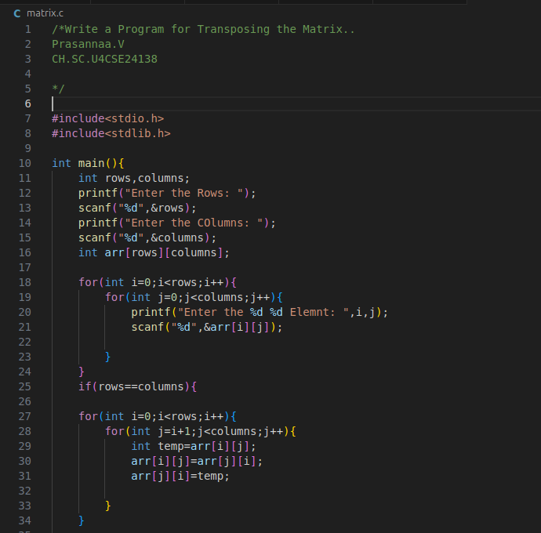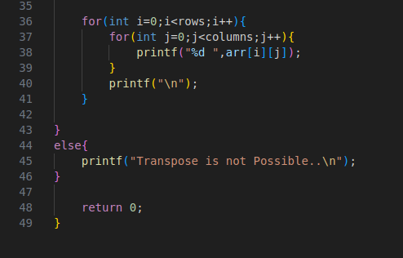

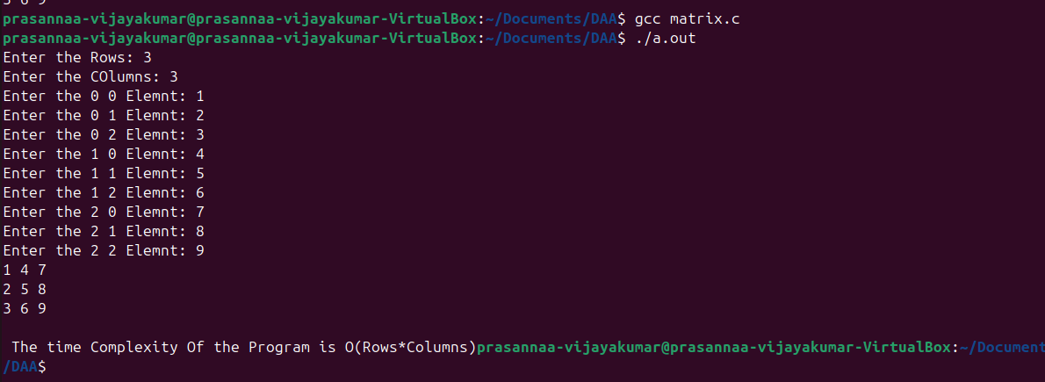
Justfication:
The space complexity of this program is O(n²) because it allocates a 2-dimensional array arr[rows][columns], whose size depends on the input.
If the matrix is square (rows = columns = n), the total memory required is n × n integers.
Since the memory grows proportionally to n², the space complexity is O(n²).

